**JAYPEE INSTITUTE OF INFORMATION, TECHNOLOGY,NOIDA**

**(Sec-62)**

**BTECH SEMESTER 3**

**PROJECT SYNOPSIS**

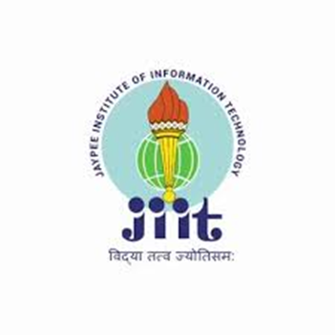

TITLE OF PROJECT

LearniVerse (Online LMS)

**In supervision of :**  Kirti Aggarwal

Kirti Jain

**Submitted by :** 23103245-Shreya Varshney

23103248-Ishit Dev Sinha

23103255-Arnav Kaushik

23103264-Piyush Panda

**PROJECT SYNOPSIS**

**INTRODUCTION**

**Description:**

The Online Learning Management System (LMS) is a web-based platform designed to facilitate the creation, delivery, and management of educational content. The LearniVerse allows teachers to create courses, upload materials, assign quizzes, and track student progress. Students can enroll in courses, access materials, participate in discussions, and take assessments. The system will include user authentication to manage different user roles such as Admin, Instructor, and Student.

**Flow Chart: -**

